The donation web service will use a microservices-based architecture with a client-server model for interaction.
We use microservices because of:
Scalability: Independent scaling of services based on load (e.g., Campaign Service can scale during high traffic).
Fault Isolation: A failure of one service (e.g., Notification) won’t affect others.
Flexibility: Services can be built using different technologies.
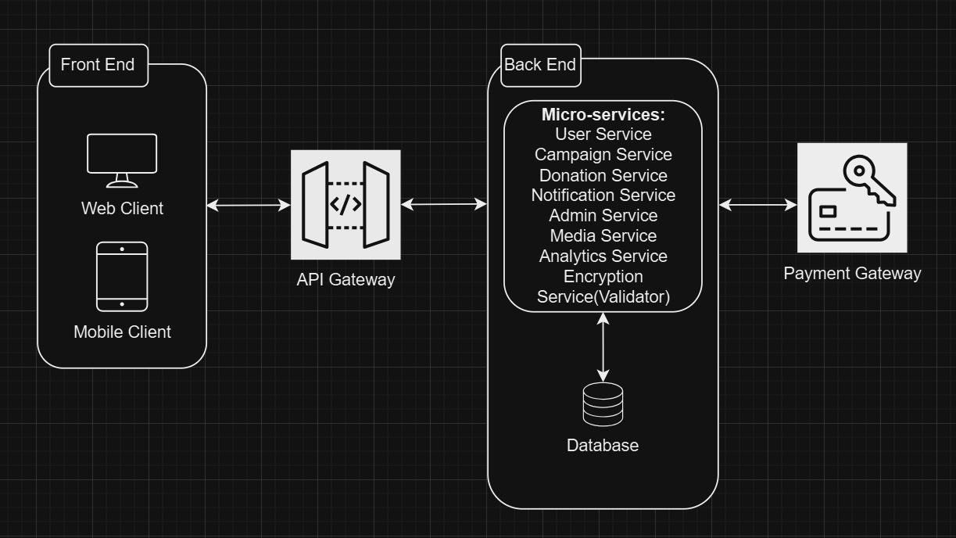
Front End
Web Client:
- Browsers interact with the service through a responsive web application;
- Allows users to browse donation campaigns, make donations, and manage their profiles.
Mobile Client:
- Native or hybrid mobile app;
- Supports push notifications and offline interaction for donations.
API Gateway
Acts as the single entry point for all client requests.
Functions:
- Routes requests to appropriate backend services.
- Provides rate-limiting, request validation, and authentication token checks.

Backend Services
- User Service:
Handles user registration, login, authentication, and profile management. Stores user details and manages roles (donor, campaign creator, admin).
- Campaign Service:
Manages CRUD operations for donation campaigns (creation, updates, visibility). Stores campaign metadata and references to associated media files.
- Donation Service:
Handles payment processing through third-party gateways. Maintains a ledger of donations and generates receipts. Supports one-time and recurring donations.
- Notification Service:
Manages real-time and scheduled notifications (email, SMS, push). Implements asynchronous processing using a message queue.
- Admin Service:
Offers tools for administrators to manage users, campaigns, and transactions. Provides reporting and analytics dashboards.
- Media Service:
Handles file uploads and retrieval for campaign images, videos, and documents. Integrates with cloud storage solutions like AWS S3 or Google Cloud Storage.
- Analytics Service:
Aggregates data from other services for real-time and historical analysis. Provides dashboards for campaign success tracking and user engagement metrics.

Interactions Between Components
Client ↔ API Gateway. The client sends HTTP/HTTPS requests to the API Gateway.
API Gateway ↔ Backend Services. Backend services interact with the API Gateway through REST or GraphQL APIs.
Backend Services ↔ Payment Gateway. The Donation Service interacts with external payment gateways for secure transactions.

Database Type
Relational Database (RDBMS):
PostgreSQL or MySQL for structured data like users, campaigns, donations, and transactions.

Cloud Storage:
Services like AWS S3 for storing campaign images, videos, and documents.

Database Structure
Users Table (RDBMS)
Donation Campaigns Table (RDBMS)
Donation Table (RDBMS)
Media Metadata Table (Cloud Storage)
Notifications Table (Cloud Storage)

Data Flow Diagram
Processes:
  - User interacts with the system (create/view campaigns, donate).
  - Payment gateway processes payments.
  - Notification system sends updates.
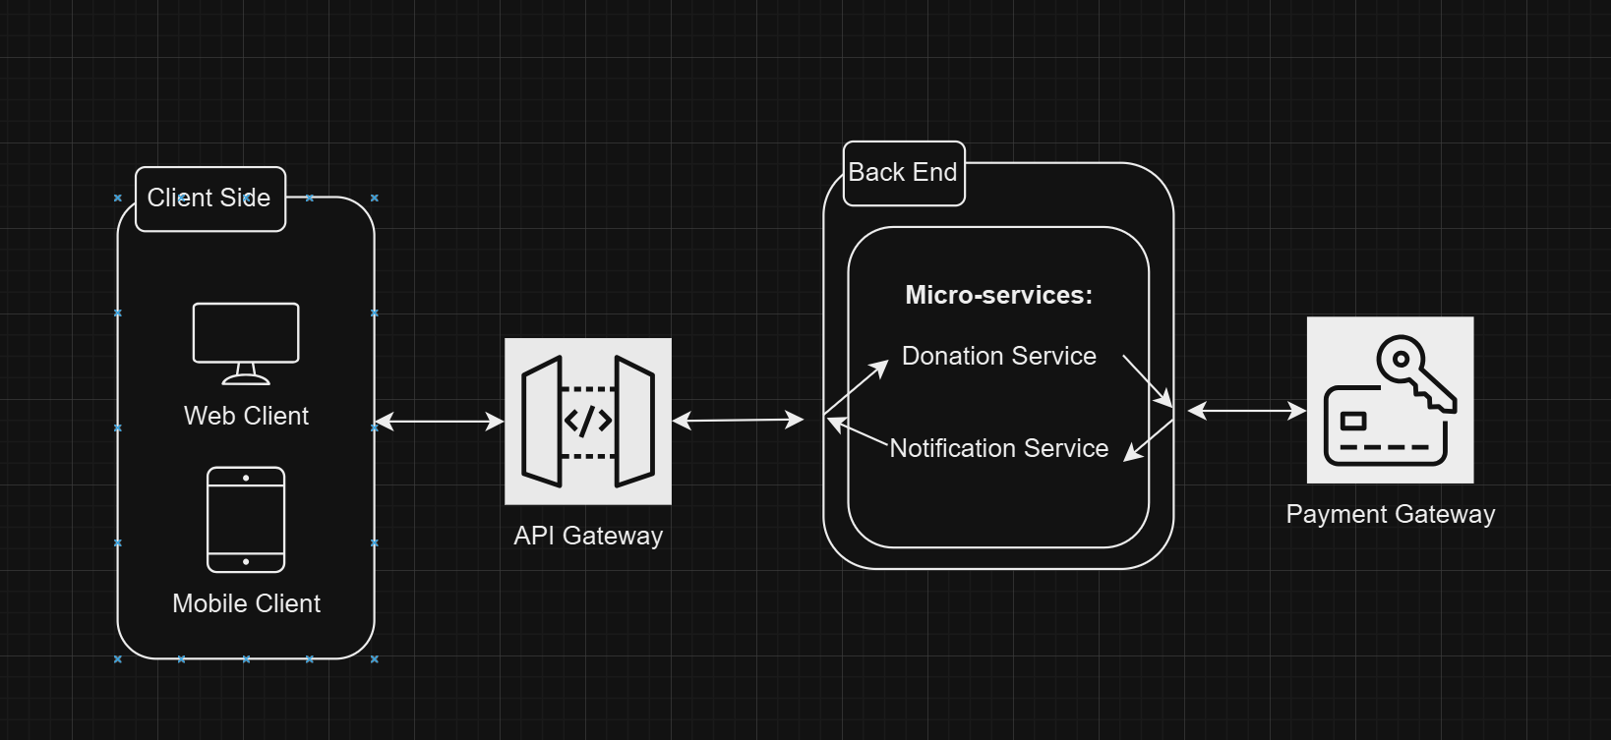

Security Test Scenarios
- SQL Injection. Validator will prevent the injection.
- Payment Rejection – in case of rejected bank transfer the website will not proceed further as there is two factor payment gateway.
Functional Test Scenarios
- User Registration. In case of duplicated email/weak password the registration would be reverted because of User Service.
Performance Test Scenarios
- High Traffic on the webservice. AWS cloud services will handle occurred issues.
Usability Test Scenarios
- Cross Platform Compatibility. UI is responsive and functions correctly and the webservice is provided for web and mobile interfaces.
- Accessibility Testing. Webservice is created by WCAG guidelines, so accessibility issues are minimized.

